SIZZLING SINGAPORE & MALAYSIA (Festive Spl.) 05 NIGHTS/06 DAYS
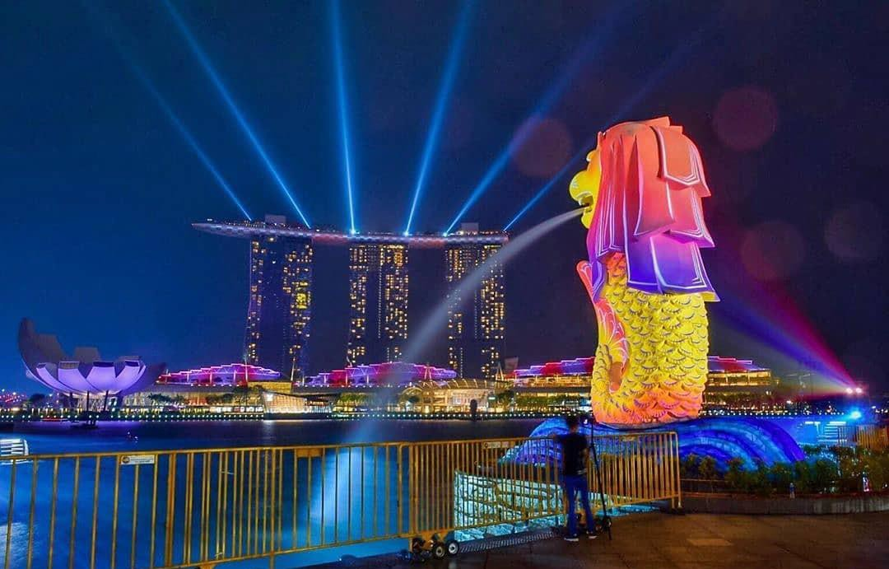
OVERVIEW: Experience the Ultimate Singapore and Malaysia Getaway with IRCTC's exclusive 'Singapore & Malaysia' tour package! Embark on a luxurious journey showcasing iconic Gardens by the Bay, thrilling Night Safari, and Sentosa Island in Singapore, and vibrant Kuala Lumpur, spiritual Batu Caves, and scenic Genting Highlands in Malaysia. Our thoughtfully crafted itinerary ensures a smooth and memorable experience, with premium accommodations, delectable cuisine, and world-class attractions – making your Southeast Asian adventure truly unforgettable.
Package Details
Package Name | SIZZLING SINGAPORE & MALAYSIA [EHO037I]
Destination Covered | Singapore-Sentosa-Malaysia-Genting Highlands-Kuala Lumpur City & Tower-Batu Caves-Putrajaya Tour
Travelling Mode | Flight (Malaysian Airlines) Ex-Kolkata
Date | 28.10.26-02.11.2026
Total seats | 30 Pax
Meal Plan | All Meals (Breakfast, Lunch & dinner)

FLIGHT DETAILS: -
Date | Flight No | From | To | Departure Time | Arrival Time
28.10.2026 | MH- 185/601 | CCU | SIN | 00:10 Hrs. | 09.05 Hrs.
02.11.2026 | MH-184 | KUL | CCU | 21.35 Hrs. | 23.10 Hrs.
The Flight timings or schedule is subject to change as per the airline’s operational feasibility

Important Key Notes:
- Format for Self Declaration Form (TCS) – Signed by individual person
- Pre-Existing Disease Form - Signed by individual person (Overseas Travel insurance for the passengers Up to age 70 years and only applicable for passengers having no preexisting diseases)
- Flight timings & itinerary are subjected to change under unavoidable circumstances.

- 2% TCS (Per PAN) till INR.7 Lakhs per individual per annum.
- 20% TCS (Per PAN) above INR.7 Lakhs per individual per annum.
- Child fare of age 0-2 years would be deposit in cash by customer at IRCTC office at the time of booking.
- TCS Tax is refundable on filling the ITR, for purchase of overseas tour program package under Clause (ii) of Sub-section (1G); the TCS shall continue to apply at the rate of 5% for the first INR. 7 Lakhs per individual per annum and the 20% rate will only apply for expenditure above this limit.
- As per Govt. of India directives TCS at the applicable rates will be additional and shall require to be deposited additional to the package amount mandatorily at IRCTC office. IRCTC shall collect the TCS @ the lower rate i.e. 05% TCS (Tax collected at Source) with an undertaking/declaration that they have not performed foreign tour of which total expenditure is not more than 07 lakhs in same FY. In case of non-submission of declaration or exceeding the threshold limit higher rate of TCS at the rate of 20 % shall be applicable. Collected TCS amount will be deposited with income tax department Govt. of India against the PAN of the customer. Customers may be able to claim refund from IT department as per Income Tax norms
Important Note
- For Advance Reservations contact IRCTC office by paying 30% of package cost per person which is non-refundable.
- Balance payment to be made 30 days prior to the date of departure.
- For booking of Infants (0-2 yrs.) contact IRCTC office.

Singapore & Malaysia- Visa Requirements: Singapore (VISA) requirements
- Passport should have validity of minimum 06 months from the date of return to India with 2 minimum blank pages.
- Filled Visa Form 14A dully signed (attached).

- 2 photographs 35 x 45mm on met finished paper with white background, face converge should be 80%. Covering letter on Plain Paper/ on letterhead – if self employed
- Bank Statement last six Months at least 80000/- INR closing balance per person. – Main applicant (last 6 months from the date of submission) - no FD accepted
- Occupation proof (Salary slip, Employee I’d card, GST Registration) / For Retired person-Retirement proof.
- Ticket & Hotel
- Student I’D card if student
- Marriage proof if spouse name not endorse in passport
- Contact detail (Email & Mobile No)
- Annual income- Last ITR filed
- Highest Academic/ Professional Qualifications Attained
- Passport Front and Back Copy.

Malaysia (MDAC) requirements
- Passport copy first and last page
- Flight & Hotel Details

[The above documents to be submitted at IRCTC office 1 (one) month before the departure date]

Tour Itinerary

DAY | DESTINATION | PARTICULARS
1 |   Kolkata – Singapore | - Assemble at Netaji Subhash International Airport 3 hrs. before flight departure
- Complete check-in formalities and board flight from Kolkata to Singapore via Kuala Lumpur at 00:10 Hrs. by
MH- 185/601
 |  | - Arrive in Singapore at 09.05 Hrs. and meet local representative at the airport.
 |  | - Half-day city tour- Merlion park, pass by City Hall & Suntec City, Chinatown
 |  | - Lunch at Indian restaurant

- Transfer to hotel for check-in
 |  | - Visit Night Safari + Tram ride
 |  | - Dinner at Indian restaurant and Overnight stay at hotel (L, D)
2 |   Singapore Sightseeing | - After Breakfast, Visit Garden by the Bay with two domes (Cloud Forest + Flower Dome)
 |  | - Lunch at Indian restaurant
 |  | - Visit Sentosa, Madame Tussauds ,Wings of Time (With Entry Charges)
 |  | - Dinner at Indian restaurant
 |  | - Overnight stay at hotel (B,L,D)
3 |   Singapore | - After Breakfast, Visit Universal Studio (Optional at guest own cost)
 |  | - Lunch at Indian restaurant
 |  | - Dinner at Indian restaurant
 |  | - Overnight stay at hotel (B,L,D)
4 | Singapore to Malaysia   | - Breakfast and then check-out from Singapore hotel
 |  | - Proceed to Malaysia
 |  | - Lunch at Indian restaurant
 |  | - Check-in at hotel
 |  | - Kuala Lumpur City tour - King Palace, National Monument , National Mosque, pass by Old Railway station, Independent Square, Twin Tower (photo stop), Chocolate gallery + Kuala Lumpur Tower (Include Observation Deck Ticket)
 |  | - Dinner at Indian restaurant & overnight stay at hotel(B,L,D)

DAY | DESTINATION | PARTICULARS
5 | Malaysia Sightseeing  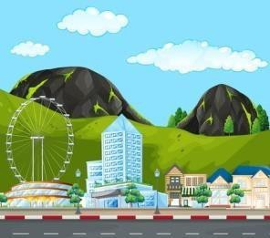 | - Breakfast
 |  | - Genting day trip with Cable Car
 |  | - Visit Batu Cave (No Theme park)
 |  | - Lunch at Indian restaurant
 |  | - Dinner at Indian Restaurant, transfer back to hotel (B,L,D)
6 | Departure from Kuala Lumpur   | - Breakfast at hotel
 |  | - Check out from hotel
 |  | - Putrajaya Tour
 |  | - Lunch at Indian restaurant
 |  | - Drop at Kuala Lumpur International airport
 |  | - Drop at airport after dinner.
- Departure flight MH-184 at 21.35 hrs. from Kuala Lumpur to Kolkata. Arrive Kolkata at
23.10Hrs.
- TOURS END WITH GOOD MEMORIES

Note: -
- Above itinerary are only a proposed / indicative holiday outline, IRCTC/ Local tour operator reserves the right to change as per the operational feasibility.
- Visit to all the sightseeing place is subject to time availability.
- IRCTC will not be responsible for any natural or social calamities.

Accommodation:

Sl.  No. | Location | No. of Nights | Hotel Name | Star Category
1 | SINGAPORE | 3N | IBIS Singapore Macpherson or Similar | 3
2 | MALAYSIA | 2N | IBIS Business Fraser Park or Similar | 3

Package Inclusion: -
  - Return Flight Tickets (Economy Class) by Malaysian Airlines ex Kolkata.
  - Singapore-Malaysia (Visa charges included).
  - Hotel Accommodation in 3*Hotel on Twin/DBL/Triple sharing basis.
  - 03 nights’ accommodation at Singapore + 02 nights’ accommodation at Kuala Lumpur
  - All Meals ( Breakfast + Lunch + Dinner)
  - Singapore city tour
  - Night Safari with tram ride
  - Garden By The Bay
  - Sentosa [Cable car Madam Tussauds +Wings of Time]
  - KL City tour +KL Tower entry ticket observation deck
  - Genting day Trip with Cable car + Batu Caves (No Theme park)
  - Putrajaya Tour
  - Sightseeing’s as mentioned above with entry fees.
  - Singapore to Kuala Lumpur transfer by road
  - All sightseeing & transfers by AC deluxe coaches with comfortable push back seats.
  - 5% GST
  - Professional and friendly English-speaking guide for entire tour program.
  - Travel Insurance included in the package for the passengers up to the age of 60 years only having No Pre-Existing diseases.

Package Exclusion: -

  - Applicable TCS.
  - Any increase in Airfare
  - Any increase in Airport Taxes, Fuel Surcharge.
  - Meals are preset & Choice of menu is not available.
  - Trip to Universal Studio
  - All Kinds of tips to guides, representative etc.
  - Any expenses of personal nature such a laundry expenses, wine, mineral water, food and drinks other than mentioned in the regular menu.
  - Any increase in rate of exchange leading to an increase in surface transportation and land arrangements which may come into effect prior to departure. The tour price is subject to increase without notice if this rate changes substantially
  - Any services not specified in the inclusion Activities of any kind are excluded in package.
  - All arrangements made by IRCTC are in the capacity of an agent; we will not be responsible for any kind of emergency such as landslide, strike, curfew, accidents, and injuries, delayed or cancelled flights, etc.

TERMS & CONDITIONS

Cancellation Policy: For cancellation of your ticket, please log in to your account, select the Tour Confirmation Number of the ticket you wish to cancel and cancel your ticket from your booked history on line. Cancellation of your Ticket is possible only on the website www.irctctourism.com, and is not possible on PRS Counters. If the user wishes to cancel his ticket, cancellation rules for International Packages are as under:

No. of days before commencement of Trip* | Total Deductions
41 days prior to departure date | 20 % of the package cost
40-31 days prior to departure date | 25 % of the package cost
30-21 days prior to departure date | 35 % of the package cost
20-15 days prior to departure date | 60 % of the package cost
14-8 days prior to departure date | 90 % of the package cost
Less than 8 Days / No Show | 100% of the package cost

Terms and Conditions:

- The request for name change will be treated as a fresh booking where confirmation will be subject to availability. Please note all bookings confirmed are non-transferable and will invite a cancellation charge as applicable.
- The journeys are planned well in advance. We reserve the right to make changes to the programme if necessary at any point of time. Should the minimum number of passengers not be met or due to certain operational reasons and conditions, we reserve the right to cancel the departure or amend the same. Most changes made by us would be minor, but on certain occasions there could be a possibility of making a significant change. A change is defined as significant if it involves a change of destination or date of departure. In such an eventuality, we would inform you as soon as possible and provide you with the following solutions: 1. accepting the changed arrangements or 2. Cancelling or accepting the cancellation where you will receive a refund of the payment remitted to us. However, there will be no refund for any service such as pre/post accommodation, airline tickets, excursions, and extensions etc. that have been booked by you and/or your Travel Agent. In case of a 'force majeure' situation due to which a departure has to be cancelled, we regret there would be no refund of the money paid to us or reimbursement of any additional expenses incurred by you as a result of our cancellation/ change.

Cancellation to be charged if booking is cancelled due to visa refusal: - Below may be retained before processing of refund –
  - Airline Cancellation Charges (If Applicable)
  - Visa Fee & Service Charge of Visa Agency
  - Insurance charge (If Applicable)
  - Cancellation paid to the service provider (If Applicable) ν. IRCTC Administration Charge - Rs. 5000/- Per Person
vi. Any other actual direct expenses incurred (If Applicable)

Taxes to be charged in case of cancelation due to visa refusal: -

  - Cancellation fee (actual expenses incurred and administration charges) is also to be taxed at 5% GST (If the original tour is also taxed @ 5% GST)
  - TCS applies to the money IRCTC actually keeps (actual expenses incurred and administration charges), not to the full original package cost.
  - Note: In case due to visa refusal of one or more pax from a group / family; other booked passengers want to cancel the tour, standard applicable cancellation may be charged. Further, wherever need of special refund is felt by the zonal / regional head the decision may be taken within the ambit of SoP.

IMPORTANT NOTE: -
    - Hotel Check in time varies between 02.00pm - 04.00pm.
    - Check out time 10.00am - 12.00 Noon.
    - Special requests like early Check In, late Check Out, Smoking room, Non-smoking room etc. will be subject to availability and hotel policy.
    - Rooms confirmed are normally Standard Category unless specified. Hotel ratings differ from county to country and facilities may not be the same in all countries.
    - Package is non-refundable after confirmation.
    - Hotels may change as per availability.
    - General Breakfast timings in hotels in Singapore & Malaysia are 06.00 - 10.00 am.
    - The airfares and taxes are calculated as on a mentioned date and any increase in the taxes or airfares will be borne by the customer.
    - Kindly ensure that your passport is valid for minimum 6 months beyond the stay, ECNR/POE formalities completed, etc.
    - 100% payment at the time of booking will be required.
    - On completion of the booking and payment formalities, a confirmation tour voucher will be generated.
    - You will have to pay all bank charges.
    - IRCTC reserves the right to decline your booking/s for any Tour or to cancel your booking without assigning any reason.

General Important Notes: -
    - Package cost is calculated on lowest class Air Fare. Airline seat confirmation is subject to availability at time of booking. Any increase in air fare or airport taxes has to be borne by the client.
    - In case there is any change in price the same will be communicated to yourself and only after your confirmation, we will proceed further. There will be no reduction for un-utilized services.
    - The package Price is subject to change without prior notice.
    - Above tour prices are subject to change in the event of increase in hotel room rates

levy by the hotel especially during peak season / holiday surcharge and major events/fairs and convention.
    - Double or twin is subject to availability and sole discretion of the hotel.
    - Passenger should get full briefing about the tour from IRCTC before/after the booking to avoid any confusion.
    - IRCTC is not liable for personnel expenses, boating, ropeway charges, porter age, theft, accidents etc.
    - Any other terms and conditions applied as may be decided by IRCTC at any point of time.

SURCHARGES:
The prices shown are based on known costs and exchange rates at the time of tour launching and IRCTC does not expect to have to make any changes. In case of unforeseen increase in national or local taxation or adverse fluctuation in currency exchange rates, affecting the cost structures of your journey, IRCTC reserves the right to impose a surcharge or revise the tour cost.

FORCE MAJEURE:
In these booking conditions, 'force majeure' means any event which we / the supplier of the service(s) in question / the Third-Party Supplier could not, even with all due care, foresee or avoid. Such events may include disruptions/diversions of air services, floods, and earthquakes whether actual or threatened war, riot, civil strife, actual or threatened terrorist activity, industrial dispute, natural or nuclear disaster, adverse weather conditions, disease, fire and all similar events outside the control of the party concerned. We cannot accept liability or pay any compensation where the performance or prompt performance of our obligations under our agreement with you is prevented or affected by, or you otherwise suffer any damage or loss as a result of, 'force majeure'

We do not accept liability for:
Any damage, loss, expense or other sum(s) of any description which based on the information you gave us at the time of booking, we could not have foreseen you would suffer or incur if we breached our contract with you. Any business losses Excursions or other tours or any other travel services taken and paid for by you which have not been provided by us whilst you are on our tour. In such instances, your contract will be with the operator / supplier of the excursion or tour or travel services and not with us

CONDITIONS OF TRAVEL:
You will have to strictly follow the tour program. There would be no refund if you fail to join the group at the commencement of the tour, or join the group later or leave the group before culmination of the tour for any reasons whatsoever. You are responsible to register with the representative of the Company at the appointed date, place and time and you would be treated as a no-show if you fail to do so. Under no circumstances would any refund be given for any unutilized services. You shall not behave in a manner which may cause distress or annoyance to other co-travelers or which may create the risk of danger or damage to property of the Company, co-travelers or others. In this event, you may be asked to leave the tour immediately. The Company shall be under no liability to any such person.

Travel Documents and Clearances:
*It shall be solely the responsibility to hold valid travel documents and statutory clearances, to enable you to travel on the Tour such as passports and medical insurance certificates and other statutory certificates including immigration clearance. In any case, your Passport must be valid for at least six months subsequent to the scheduled departure date (Return) of the tour.

*As granting or rejecting visas and immigration clearance is the sole prerogative of the concerned sovereign governments, IRCTC shall neither be responsible in case of non- granting of such documents nor liable for any delay, denial or other related act/omission or for any loss, expense, damage or cost resulting there from. The position in respect of cancellation of Tour by Client due to non-availability of travel documents would not change only by virtue of the Client having applied for such documents through the Operator. Even if visas are rejected, the stipulated fees of the Operator shall be payable by the Client. There will be no refund to the Client, or any member of his party, is unable to travel due to the said reasons. In such cases, the non-refundable deposit paid by the clients shall be forfeited and no claim whatsoever shall be made for the same.

Extra Bed:
Three person of one family on one booking will be accommodated in one double room with an extra bed.
Child will be accommodated in one room with the parents only

